1)

Code:

CREATE DATABASE sales;

USE sales;

CREATE TABLE purchase (

ord_no INT,

purch_amt DOUBLE,

ord_date DATE,

customer_id INT,

salesman_id INT

);

INSERT INTO purchase (ord_no,purch_amt,ord_date,customer_id,salesman_id)

VALUES

( 70001,150.5, "2012-10-05",3005,5002),

(70009,270.65, "2012-09-10",3001,5005),

(70002,65.26, "2012-10-05",3002,5001),

(70004,110.5, "2012-08-17",3009,5003),

(70007,948.5, "2012-09-10",3005,5002),

(70005,2400.6, "2012-07-27",3007,5001),

(70008, 5760, "2012-09-10",3002,5001),

(70010,1983.43,"2012-10-10",3004,5006),

(70003,2480.4, "2012-10-10",3009,5003),

(70012,250.45, "2012-06-27",3008,5002),

(70011,75.29, "2012-08-17",3003,5007),

(70013,3045.6, "2012-04-25",3002,5001)

;

DELETE FROM purchase;

DROP TABLE purchase;

DROP DATABASE sales;

Tables:

* Purchases:

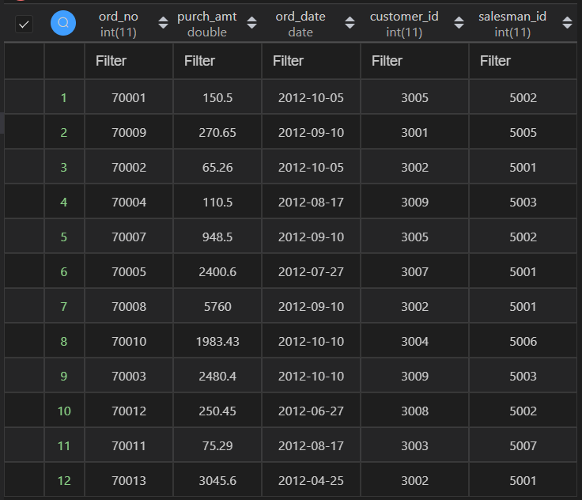

Queries/Outputs:

* SELECT MIN(purch_amt) FROM purchase;

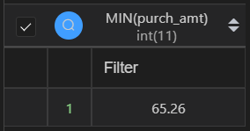

* SELECT MIN(purch_amt) FROM purchase;

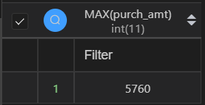

* SELECT MIN(purch_amt) FROM purchase;

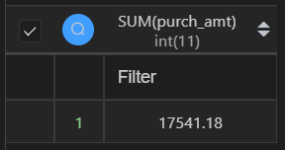

* SELECT AVG(purch_amt) FROM purchase;

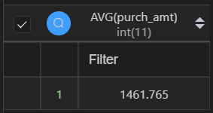

* SELECT COUNT(DISTINCT customer_id) FROM purchase;

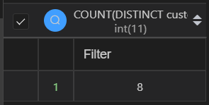

* ALTER TABLE purchase ADD warranty date ;

UPDATE purchase SET warranty = DATE_ADD(ord_date , INTERVAL 6 MONTH);

SELECT * FROM purchase;

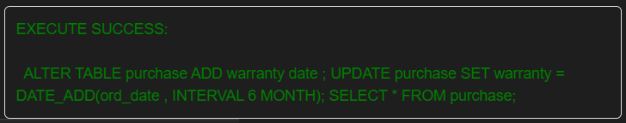

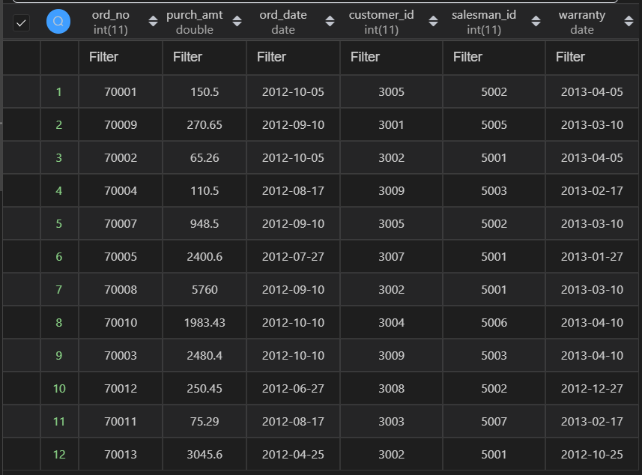

* (SELECT * FROM purchase ORDER BY ord_date ASC LIMIT 1)

UNION (SELECT *FROM purchase ORDER BY ord_date DESC LIMIT 1

;

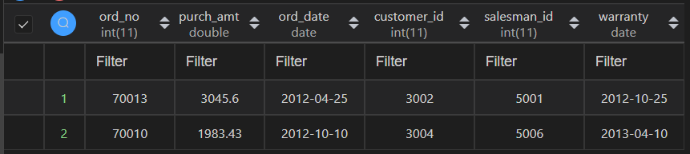

* SELECT DATE_ADD(ord_date, INTERVAL 1 DAY) AS NextDay FROM purchase ;

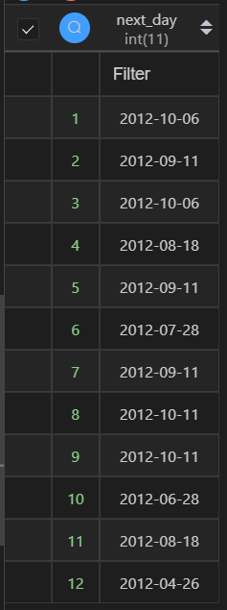

* (SELECT FLOOR(purch_amt) FROM purchase ORDER BY purch_amt ASC LIMIT 1)

UNION (SELECT CEIL(purch_amt) FROM purchase ORDER BY purch_amt DESC LIMIT 1)

;

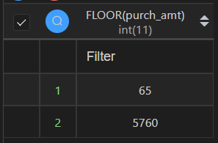

* SELECT ROUND(purch_amt, 1) FROM purchase;

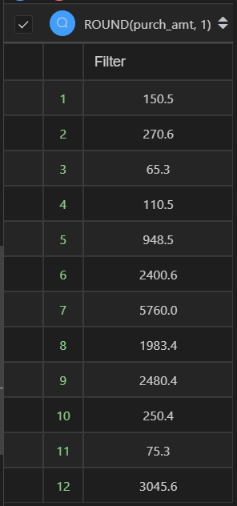

2)

Code:

CREATE DATABASE Customer;

USE Customer;

CREATE TABLE CustInfo (

CustId VARCHAR(5) PRIMARY KEY,

CustName VARCHAR(25),

CustAdd VARCHAR(50),

Phone BIGINT(10),

Email VARCHAR(25),

CHECK (CustId like "C%"),

CHECK (Email like "%@%")

);

INSERT INTO CustInfo

VALUES

("C0001", "AmitSaha", "L-10, Pitampura", 4564587852, "amitsaha2@gmail.com"),

("C0002", "Rehnuma", "J-12, SAKET", 5527688761, "rehnuma@hotmail.com"),

("C0003", "CharviNayyar", "10/9, FF, Rohini", 6811635425, "charvi123@yahoo.com"),

("C0004", "Gurpreet", "A-10/2, SF, MayurVihar", 3511056125, "gur_singh@yahoo.com")

;

DELETE FROM CustInfo;

DROP TABLE CustInfo;

DROP DATABASE Customer;

Tables:

* Customer info

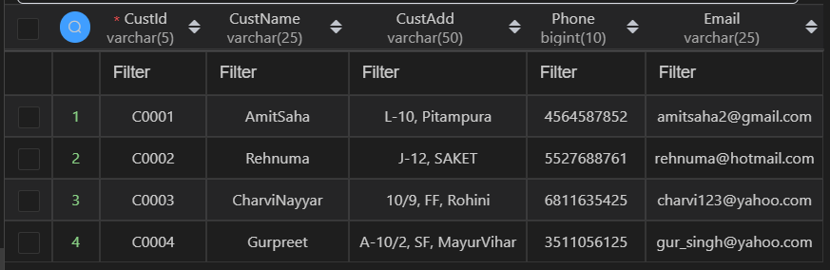

Queries/Outputs:

* SELECT LOWER(CustName), UPPER(Email) FROM CustInfo;

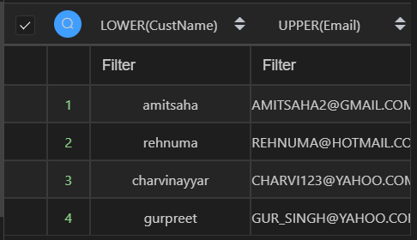

* SELECT TRIM(TRAILING '.com' FROM Email) AS Trimmed_Email FROM CustInfo;

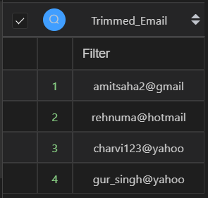

* SELECT CustName, LENGTH(CustName) AS Length_CustName FROM CustInfo;

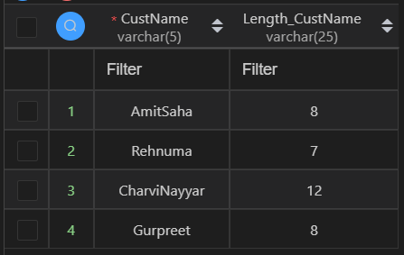

* SELECT CONCAT(CustId, CustName) AS IdName,

POSITION('A' in CustName) AS PosA

FROM CustInfo;

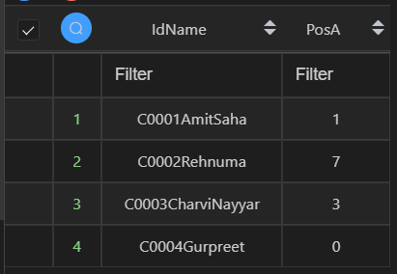

* SELECT * FROM CustInfo WHERE CustName LIKE '%a';

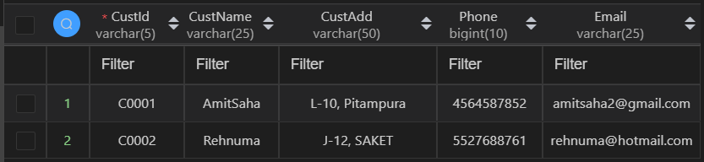

* SELECT SUBSTR(Email, 2, 3) AS d_Email FROM CustInfo;

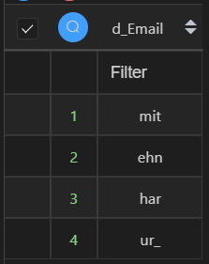

* SELECT SUBSTRING(CustAdd, 1, 20) AS d_CustAdd FROM CustInfo;

